HTML DEMO SCREENSHOTS

1. Step 1: Dashboard Display
When the program starts, the dashboard is displayed.
It shows the ransomware detection environment along with the dataset (CSC environment) used for analysis. This dashboard gives an overview of the system.
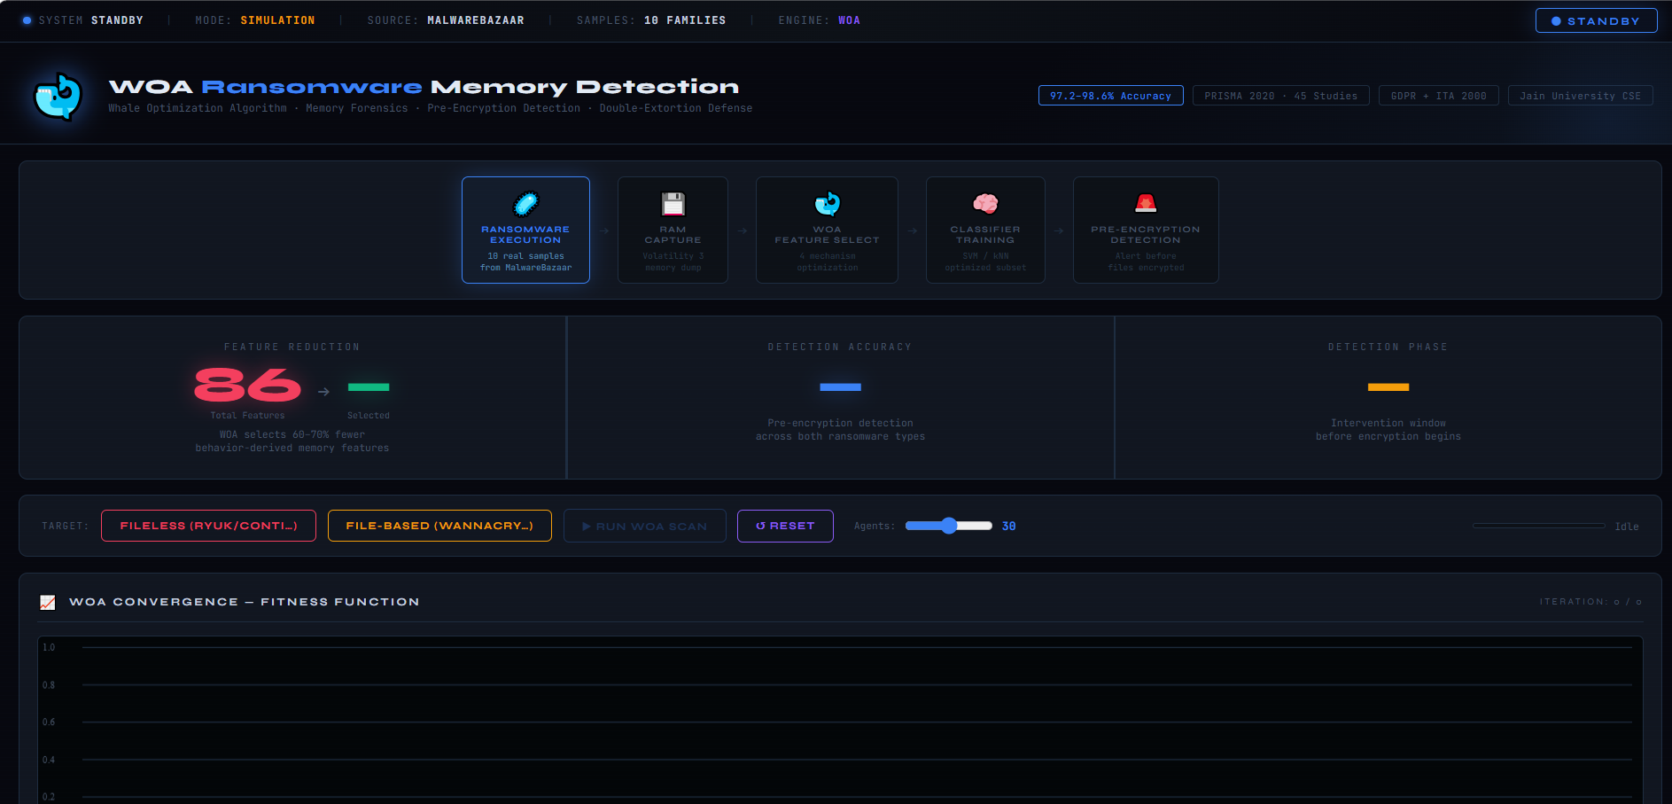

2. Step 2: Selection of Ransomware Sample
The user selects a ransomware sample from the available options in the system.
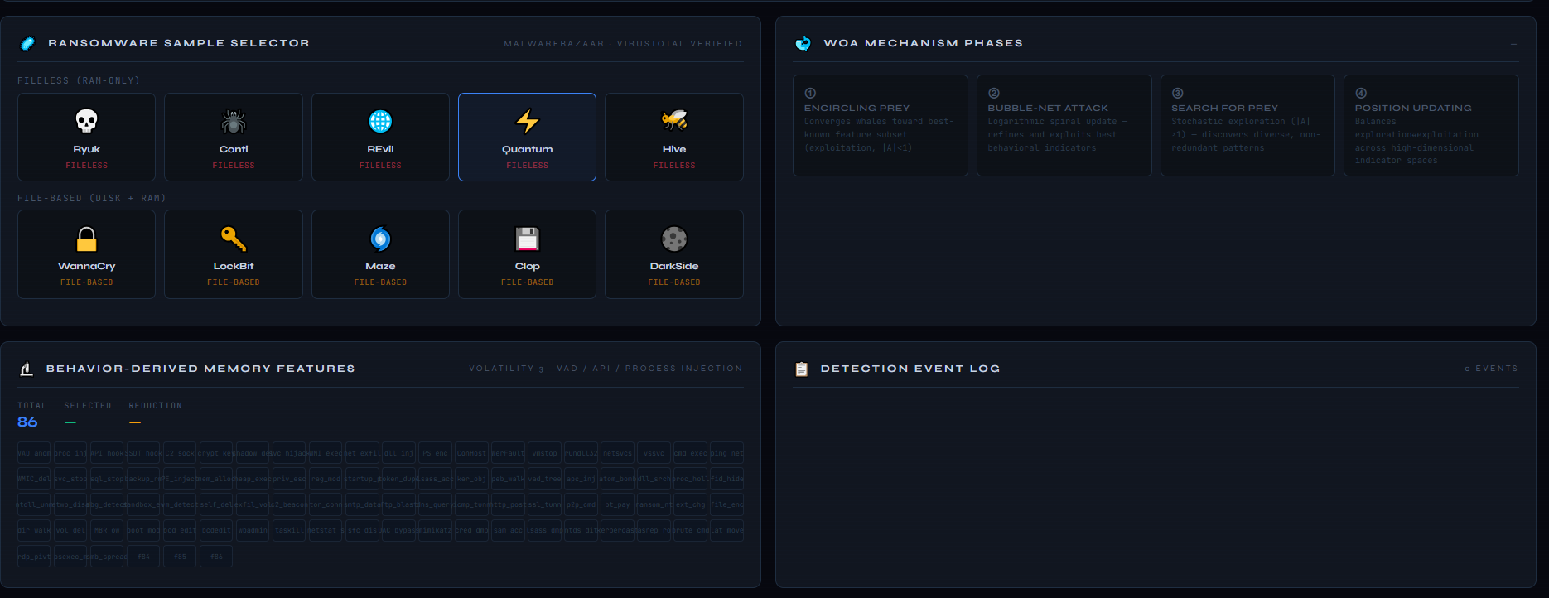

3. Step 3: Detection Initialization
After selecting the ransomware sample, the detection module is activated and the system prepares for analysis.
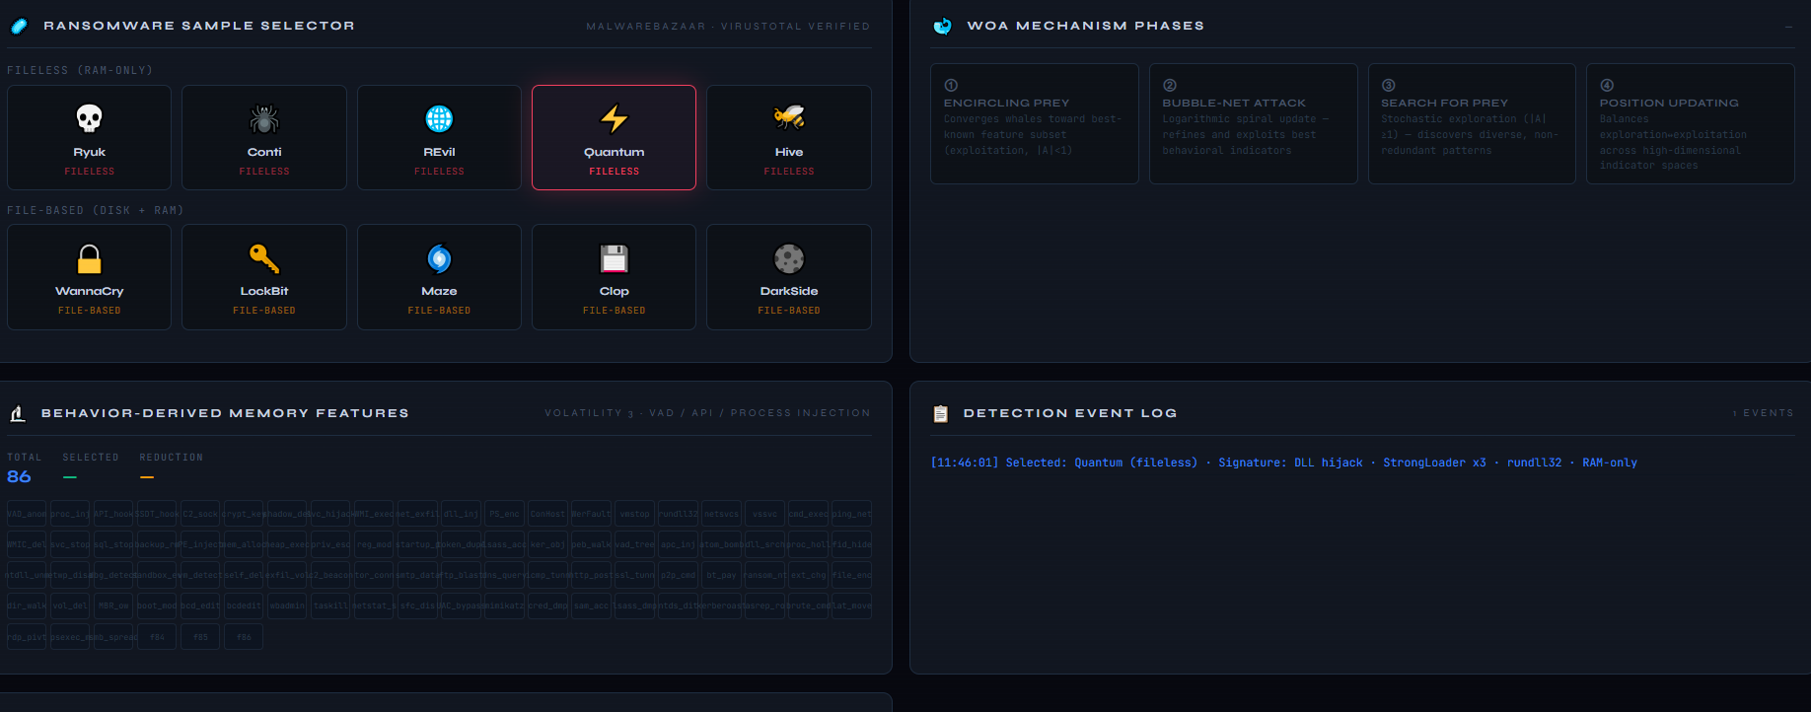

4. Step 4: Running the Sample
The selected ransomware sample is executed within the system to begin the detection process.
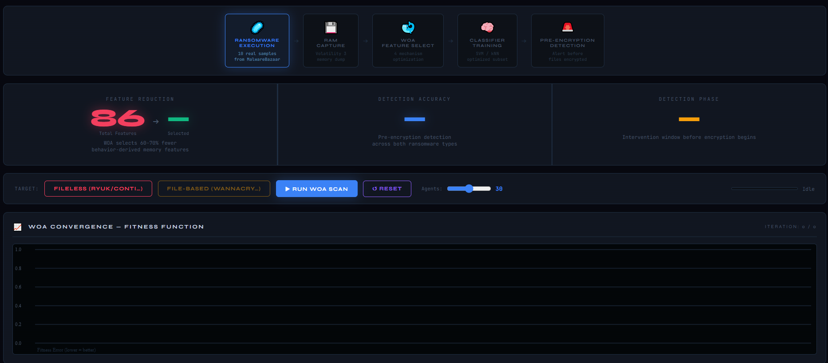

5. Step 5: Fitness Convergence Curve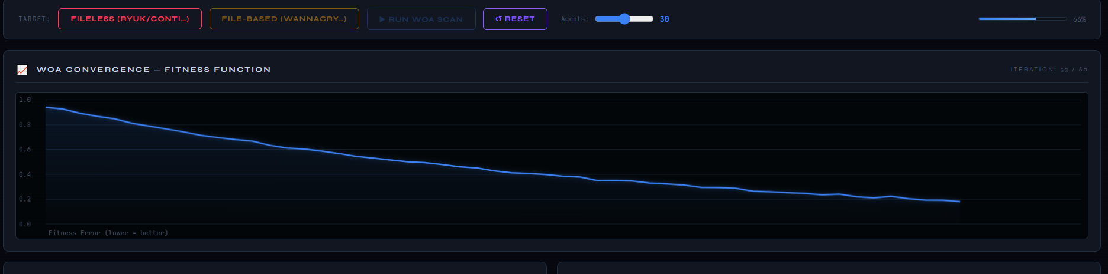

6. Step 6: Final Output Display
After the optimization and analysis are completed, the final result is displayed.
This includes:
- Detected ransomware name
- Accuracy
- Selected features
- Reduction percentage
- Behavioral indicators
